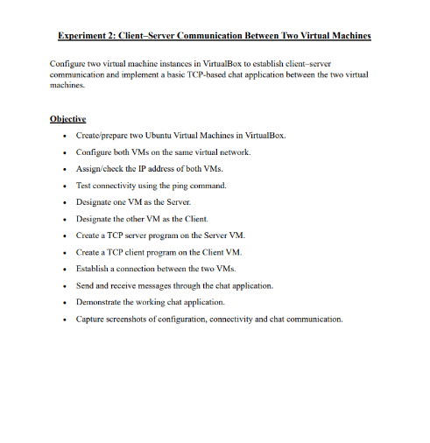
STEP 1 : Creating and preparing two Ubuntu Virtual Machines in VirtualBox
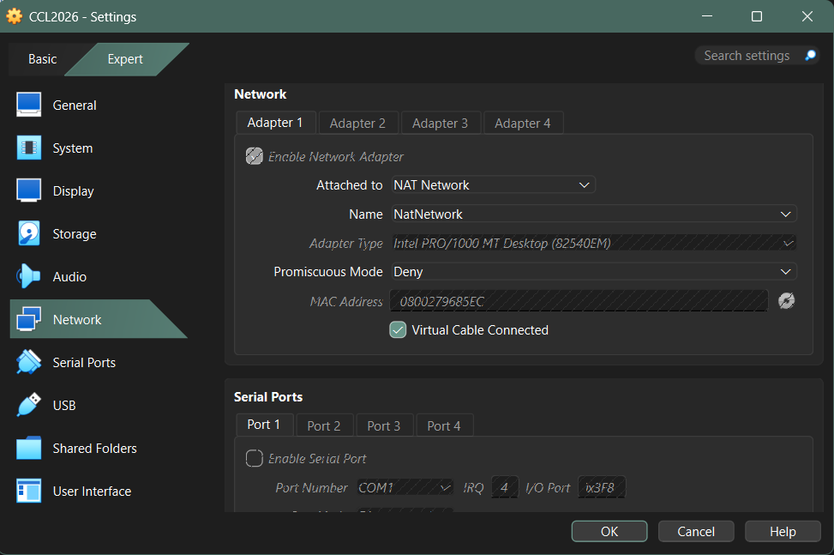
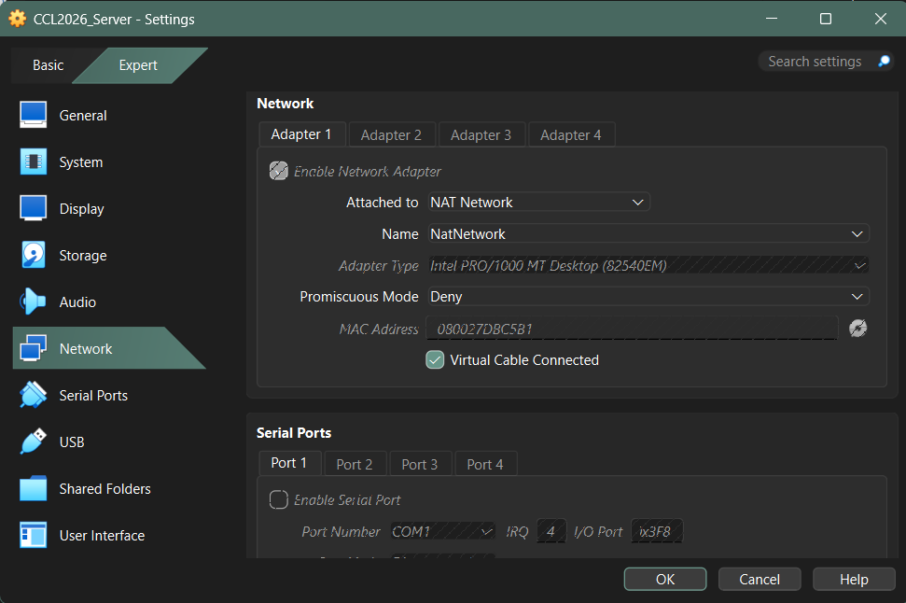
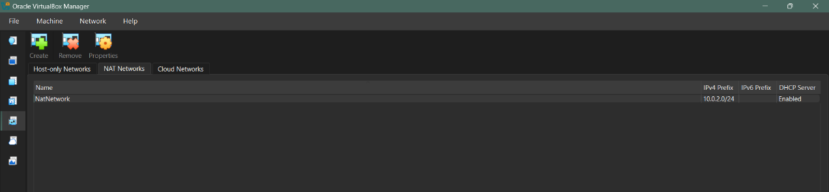
STEP 2 : Configure both VMs on the same virtual network.

STEP 3 : Checking IP address of Both VMs
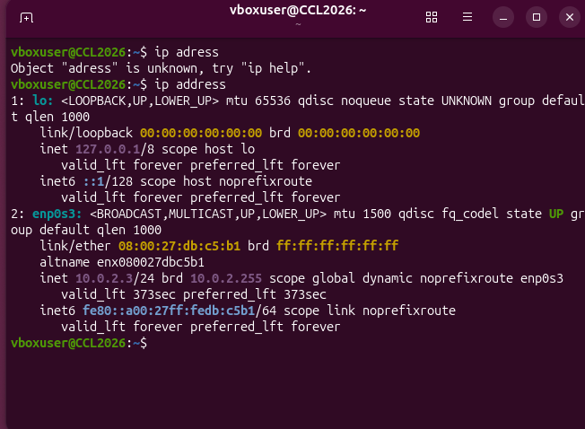
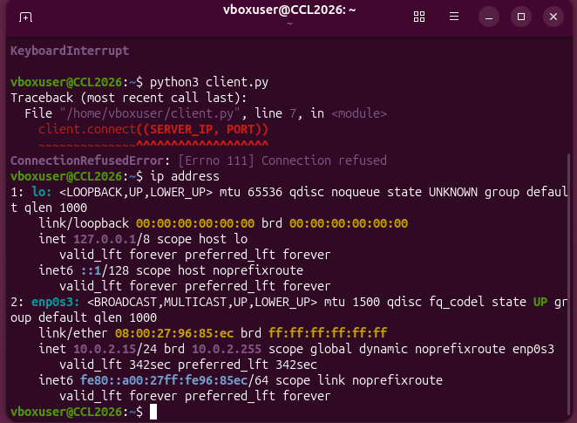
STEP 4 : Testing connectivity using the ping commad
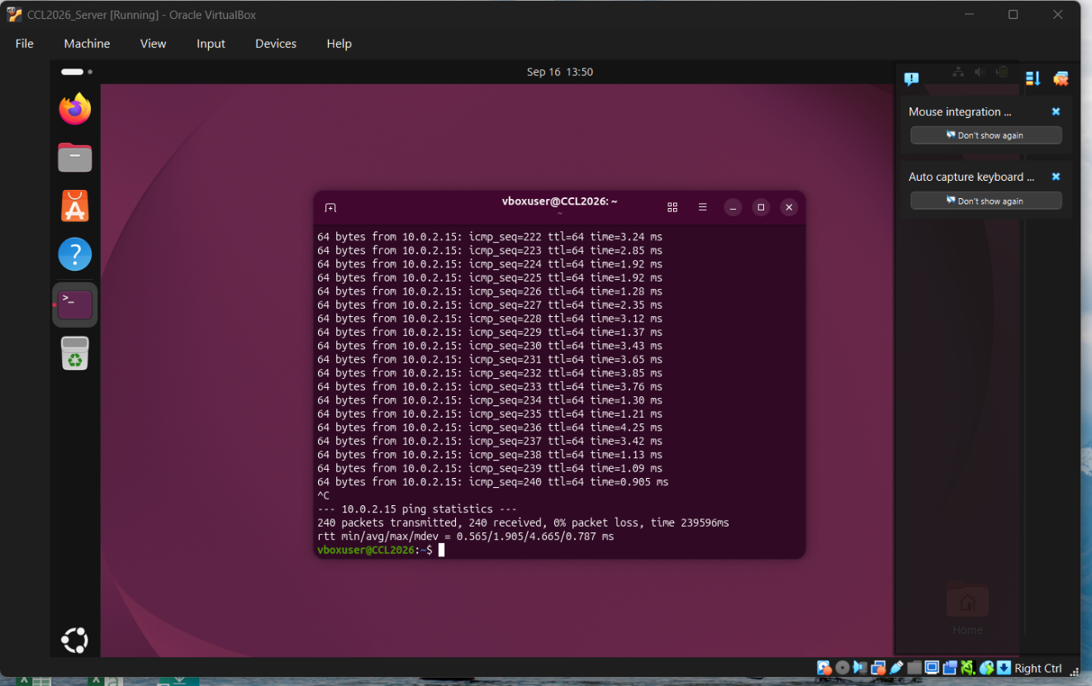
STEP 5: Designate one VM as the Server.
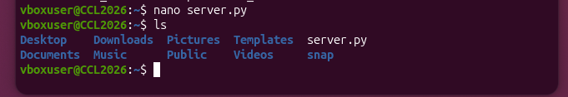
STEP 6: Designate the other VM as the Client
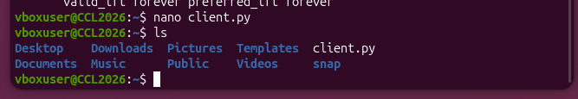
STEP 7 : Create a TCP server program on the Server VM
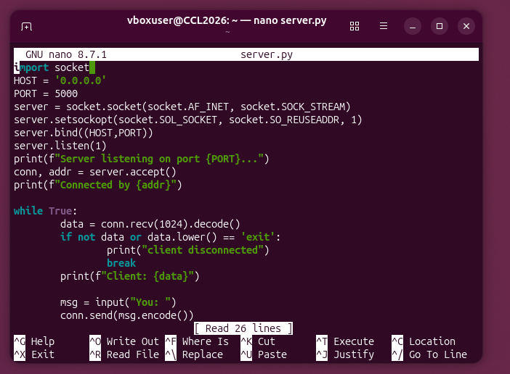

STEP 8 : Create a TCP server program on the client VM
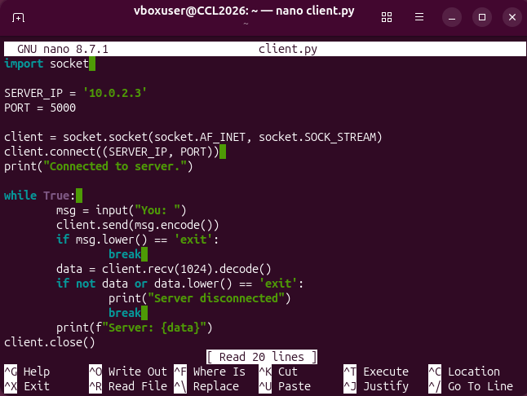

STEP 9 : Establishing a connection between the two VMs.
STEP 10 : Sending and receiving messages through the chat application.
